**Parallel Programming - Assignment 4**

Ryan Manske, Kiana McNellis, Rob Russo

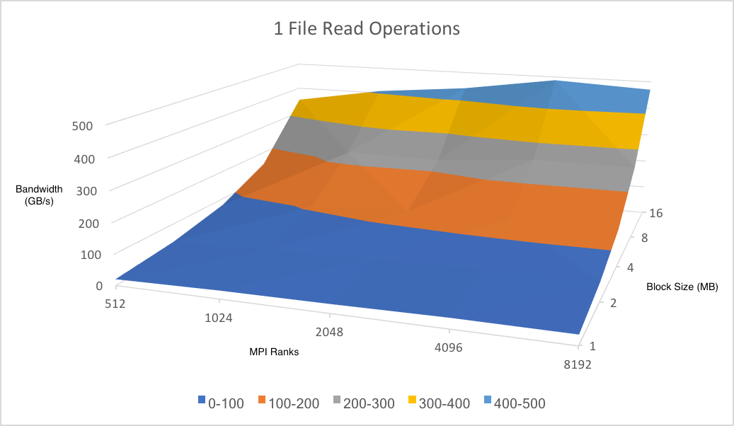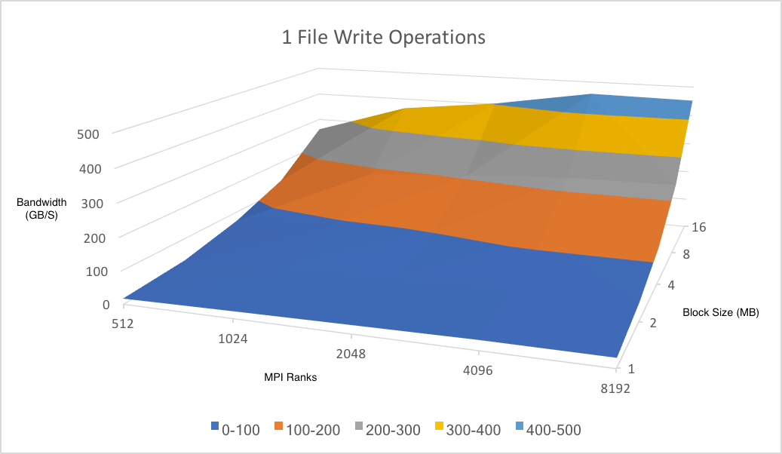

The above two graphs show parallel read and write performance on a single file. Both graphs indicate a positive correlation between the number of MPI Ranks and the bandwidth reached. Both graphs tend to peak around 4096 ranks and plateau following that. Performance also increases as the number of files being written increases. This makes logical sense, as higher bandwidths cannot be reached without more data to process. Peak performance hits near 500 GB/s for both reads and writes, with reads slightly higher. Based on these graphs, reads seem to be faster than write overall. At nearly all points the values are similar, but always favoring the performance when doing a read.

